# Project Name

# A CRM Application to Manage the Booking of Co-Living

By-Ekta Gupta

Email Id- murarilalg28@gmail.com

### 

### Abstract: CRM Application for Managing Co-Living Space Bookings

The Co-Living Space CRM (Customer Relationship Management) application is designed to enhance the experience of residents in a shared living environment by providing a seamless way to manage bookings, services, and interactions. This application is tailored to support a community-centric living model where individuals can live, work, and engage with others in a dynamic and supportive environment.

**Key Features:**

1. **Resident Management:** The application stores and manages detailed customer profiles, allowing for easy tracking of resident preferences, room selections, and service usage.
2. **Room Booking System:** Residents can book different types of air-conditioned rooms with multiple sharing options, catering to various needs and preferences. The application provides an intuitive interface to browse available rooms and make reservations.
3. **Service Selection:** Residents have the option to choose from a range of special food items daily, tailored to their dietary preferences. The application facilitates easy selection and customization of meal plans.
4. **Payment Processing:** The CRM supports multiple payment modes, ensuring residents can securely and conveniently pay for their bookings and selected services.
5. **Feedback Mechanism:** To maintain high standards of service, the application includes a feedback system where residents can rate and comment on various services, such as room cleaning, internet connectivity, and food quality. This feedback is crucial for continuous improvement and maintaining resident satisfaction.

**Objective:**  
The primary objective of this CRM application is to create a vibrant and inclusive co-living environment that fosters collaboration, reduces isolation, and enhances the overall quality of life for residents. By integrating resident management, service customization, and feedback collection into a single platform, the application aims to streamline operations, improve service delivery, and build a strong community spirit within the co-living space.

# TASKS

1. Salesforce
2. Object
3. Tabs
4. The Lightning App
5. Field & Relationship
6. Validation Rule
7. Profile
8. User
9. Role
10. User adoption
11. Reports
12. Dashboard
13. Flows

### Task 1- Creating Developer Account

Creating a developer org in salesforce.   
1. Go to <https://developer.salesforce.com/signup>  
2. On the sign up form, enter the following details :

[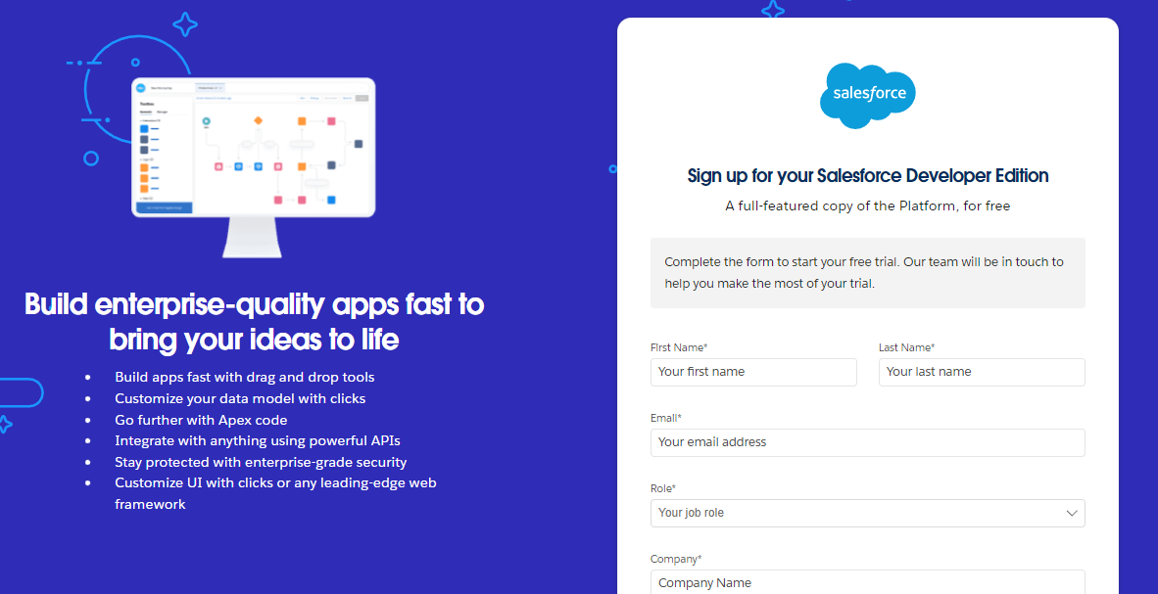](https://developers.salesforce.com/Signup*)

1. First name & Last name
2. Email
3. Role : Developer
4. Company : College Name
5. County : India
6. Postal Code : pin code

Username : should be a combination of your name and company  
This need not be an actual email id, you can give anything in the format : username@organization.com   
Click on sign me up after filling these.

### Task 2- Account Activation

1. Go to the inbox of the email that you used while signing up. Click on the verify account to activate your account. The email may take 5-10mins.  
2. Click on Verify Account  
3. Give a password and answer a security question and click on change password.  
4. when you will redirect to your salesforce setup page.

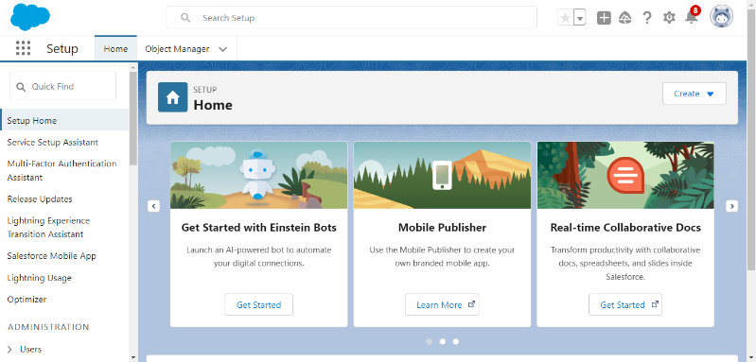

### Task 3-Create a custom object for Customer

To create a custom object, follow these steps:

1. From setup click on object manager.
2. Click create, select custom object.
3. Fill in the label as " Customer1 ".
4. Fill in the plural label as " Customers ".
5. Record name: "Customer Name"
6. Select the data type as "Text".
7. In the Optional Features section, select Allow Reports and Track Field History.
8. In the Deployment Status section, ensure Deployed is selected.
9. In the Search Status section, select Allow Search.
10. In the Object Creation Options section, select Add Notes and Attachments related list to default page layout.
11. Leave everything else as is, and click Save.

### Create a custom object for Room Booking

To create a custom object, follow these steps:

1. From setup click on object manager.
2. Click create, select custom object.
3. Fill in the label as " Room Booking ".
4. Fill in the plural label as " Room Bookings ".
5. Record name: "Room No "
6. Select the data type as "Auto number ".
7. Under Display format enter RN-{000}
8. Enter starting Number as 1
9. In the Optional Features section, select Allow Reports and Track Field History.
10. In the Deployment Status section, ensure Deployed is selected.
11. In the Search Status section, select Allow Search.
12. In the Object Creation Options section, select Add Notes and Attachments related list to default page layout.
13. Leave everything else as is, and click Save.

### Create a custom object for Payment

To create a custom object, follow these steps:

1. From setup click on object manager.
2. Click create, select custom object.
3. Fill in the label as " Payment1".
4. Fill in the plural label as " Payments ".
5. Record name: "Payment No "
6. Select the data type as "Auto number ".
7. Under Display format enter PNO-{000}
8. Enter starting Number as 1
9. In the Optional Features section, select Allow Reports and Track Field History.
10. In the Deployment Status section, ensure Deployed is selected.
11. In the Search Status section, select Allow Search.
12. In the Object Creation Options section, select Add Notes and Attachments related list to default page layout.
13. Leave everything else as is, and click Save.

### Create a custom object for Food Selection

To create a custom object, follow these steps:

1. From setup click on object manager.
2. Click create, select custom object.
3. Fill in the label as " Food Selection ".
4. Fill in the plural label as " Food Selections ".
5. Record name: " Food Selection No "
6. Select the data type as "Auto number ".
7. Under Display format enter FS No-{000}
8. Enter starting Number as 1
9. In the Optional Features section, select Allow Reports and Track Field History.
10. In the Deployment Status section, ensure Deployed is selected.
11. In the Search Status section, select Allow Search.
12. In the Object Creation Options section, select Add Notes and Attachments related list to default page layout.
13. Leave everything else as is, and click Save.

### Create a custom object for Feedback

To create a custom object, follow these steps:

1. From setup click on object manager.
2. Click create, select custom object.
3. Fill in the label as " Feedback ".
4. Fill in the plural label as " Feedbacks ".
5. Record name: "Feedback No "
6. Select the data type as "Auto number ".
7. Under Display format enter Fd No-{0000}
8. Enter starting Number as 1
9. In the Optional Features section, select Allow Reports and Track Field History.
10. In the Deployment Status section, ensure Deployed is selected.
11. In the Search Status section, select Allow Search.
12. In the Object Creation Options section, select Add Notes and Attachments related list to default page layout.
13. Leave everything else as is, and click Save.

### Task4 -Creating a Tab for Total Rooms

**To create a Tab:(Total Rooms)**1. Go to setup page > type Tabs in Quick Find bar > click on tabs > New (under custom object tab)

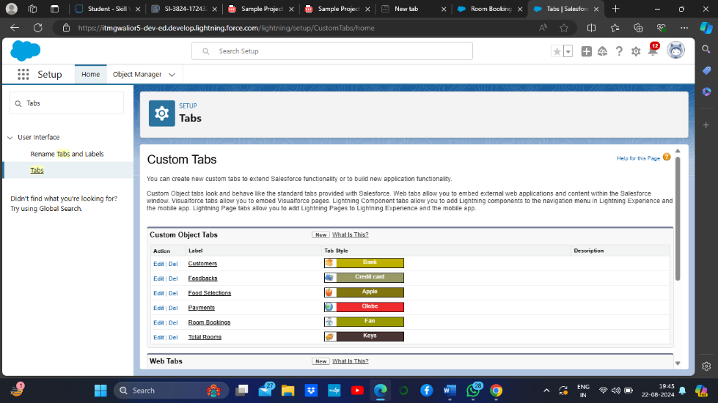

2. Select Object(Total Rooms) > Select the tab . 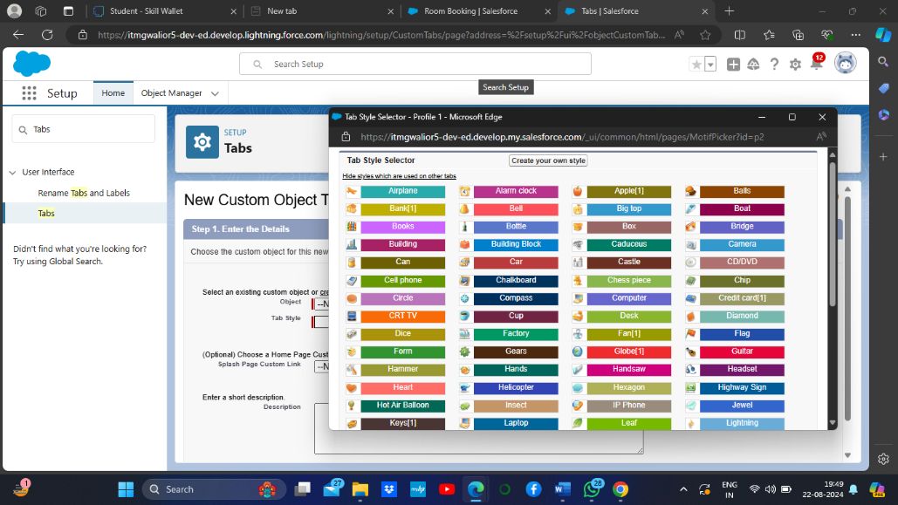

3. Next (Add to profiles page) keep it as default

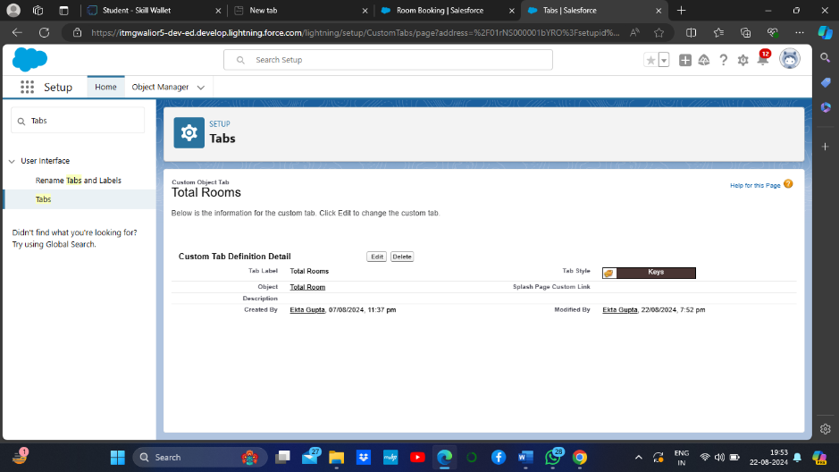

To create a Tab:(Customers)

1. Go to setup page > type Tabs in Quick Find bar > click on tabs > New (under custom object tab)
2. Select Object(Customers) > Select the tab style > Next (Add to profiles page) keep it as default > Next (Add to Custom App) keep it as default > Save.

### To create a Tab for Room Bookings

To create a Tab:(Room Bookings)

1. Go to setup page ? type Tabs in Quick Find bar ? click on tabs ? New (under custom object tab)
2. Select Object(Room Bookings) ? Select the tab style ? Next (Add to profiles page) keep it as default ? Next (Add to Custom App) keep it as default ? Save

### Create a Tabs For Remaining Objects

Now create the tabs for Payments, Food Selections, Feedbacks Objects.

### Task5- Create a Lightning App

### **To create a lightning app page:** 1. Go to setup page > search “app manager” in quick find > select “app manager” > click on New lightning App

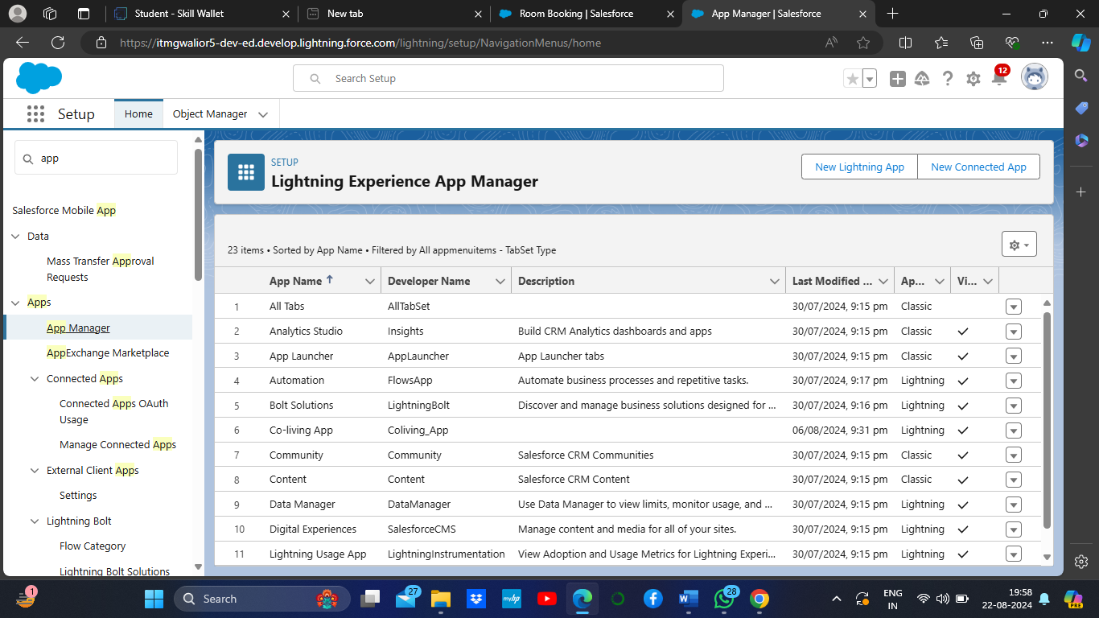

1. Fill the app name in app details and branding > Next  > (App option page) keep it as default > Next > (Utility Items) keep it as default > Next.

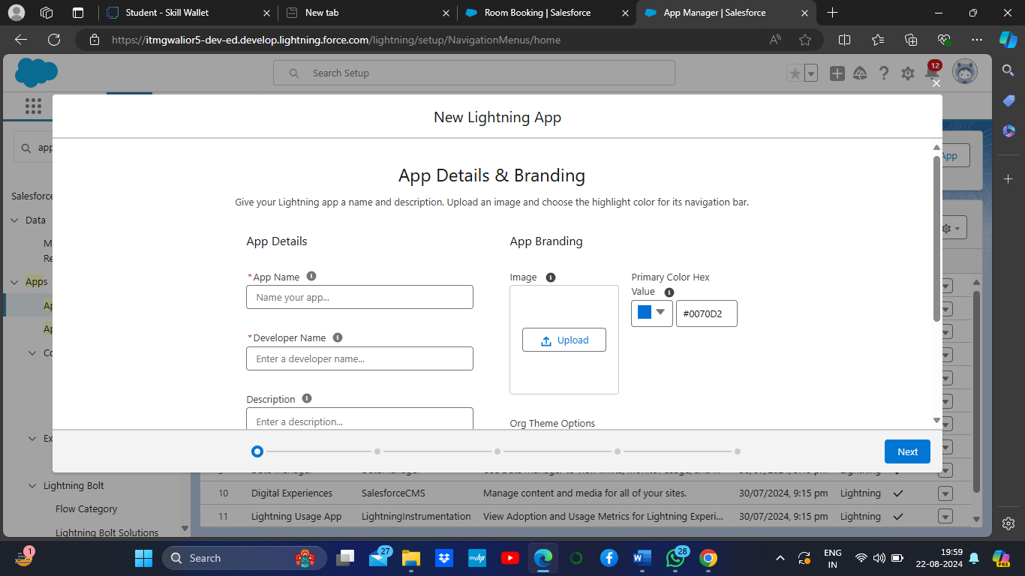

1. To Add Navigation Items: Ctrl and Select the items (Total Rooms, Customers1, Room Booking, Payments1, Food selection, Feedbacks, Reports and Dashboards) from the sear bar and move it using the arrow button > Next

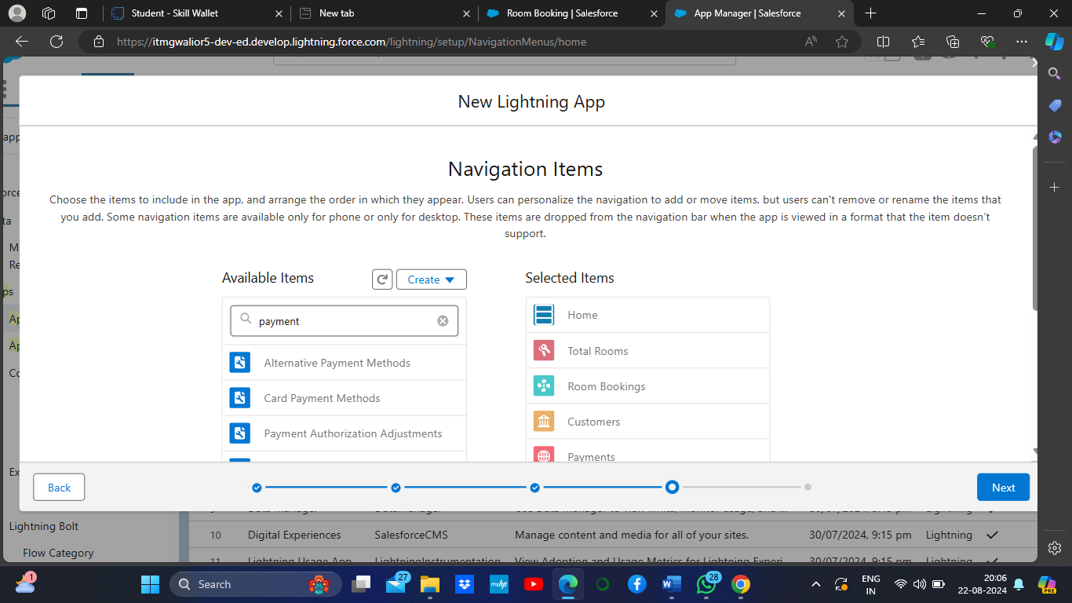

1. To Add User Profiles:

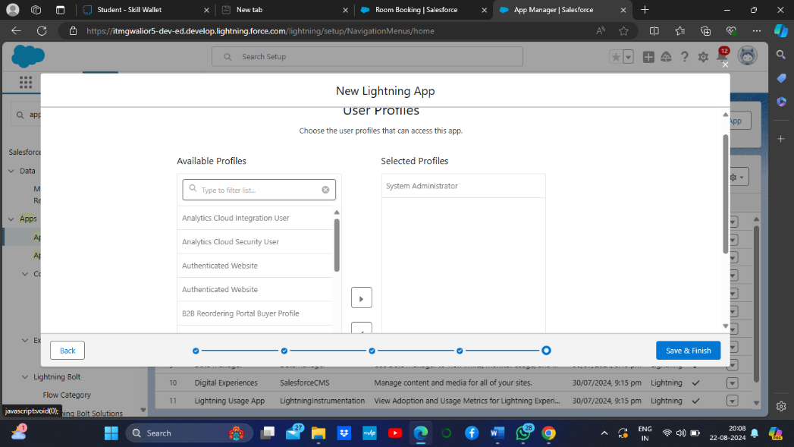

1. Search profiles (System administrator) in the search bar > click on the arrow button > save & finish.

### Creation of fields for the customer1 object

1. **To create fields in an object:**1. Go to setup > click on Object Manager > type object name(Customer1) in search bar > click on the object.

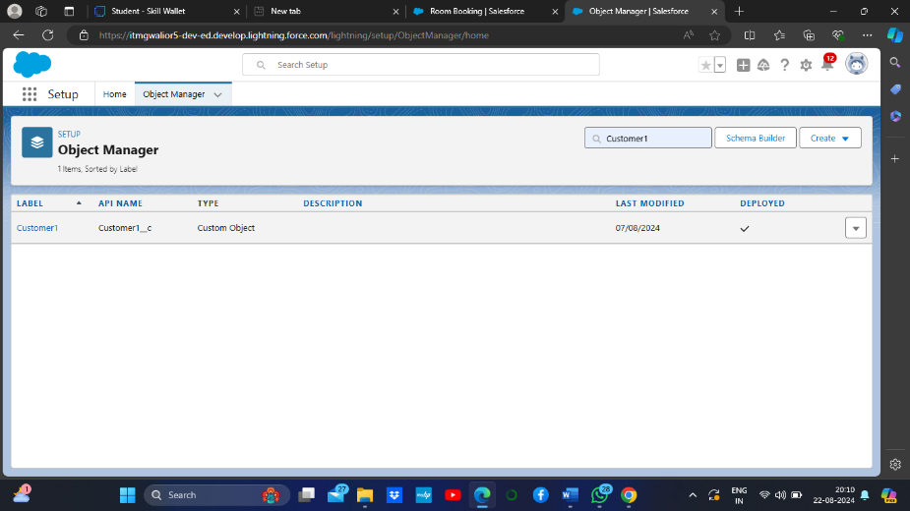

1. Now click on “Fields & Relationships” > New

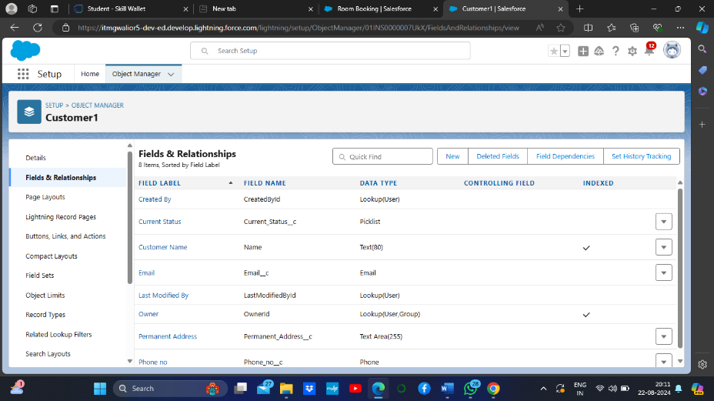

1. Select Data Type as a “Phone”

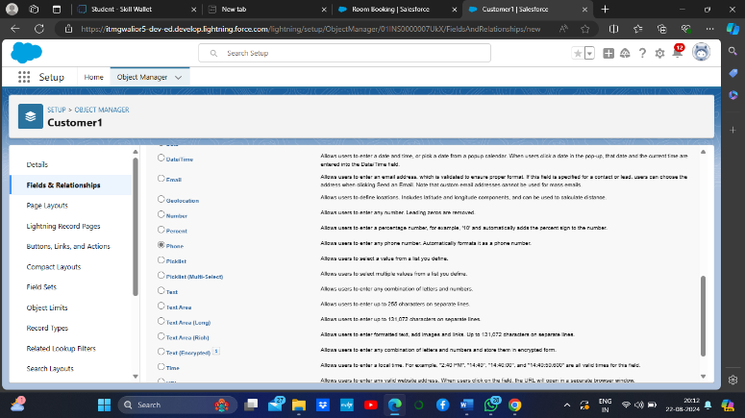

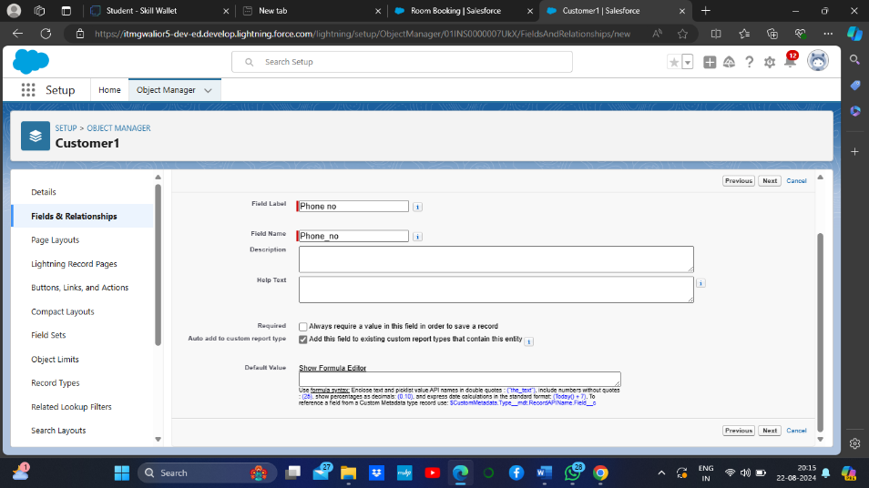

5. Fill the Above as following:

1. Field Label: Phone no
2. Field Name : gets auto generated
3. Click on Next > Next > Save and new.

**2. To create another fields in an object:**

1. Go to setup > click on Object Manager > type object name(Customer1) in search bar > click on the object.
2. Now click on “Fields & Relationships” > New
3. Select Data type as a “Email” and Click on Next
4. Fill the Above as following:

* Field Label: Email
* Field Name :It’s  gets auto generated
* Click on Next > Next > Save and new.

**3. To create another fields in an object:**

1. Go to setup > click on Object Manager > type object name(Customer1) in search bar > click on the object.
2. Now click on “Fields & Relationships” ? New
3. Select Data type as a “Text Area” and Click on Next
4. Fill the Above as following:

* Field Label: Permanent Address
* Field Name : It’s gets auto generated
* Click on Next > Next > Save and new.

**4. To create another fields in an object:**

1. Go to setup > click on Object Manager > type object name(Customer1) in search bar > click on the object.
2. Now click on “Fields & Relationships” > New
3. Select Data type as a “Picklist” and Click on Next
4. Fill the Above as following:

* Field Label: Current Status
* Value - Select enter values with each value separated by a new line

1. Student
2. Employee
3. Others

* Select required
* Field Name :It’s gets auto generated
* Click on Next > Next > Save and new.

### Creation of fields for the Room Booking object

**1. To create fields in an object:**

1. Go to setup > click on Object Manager > type object name(Room Booking) in the search bar > click on the object.

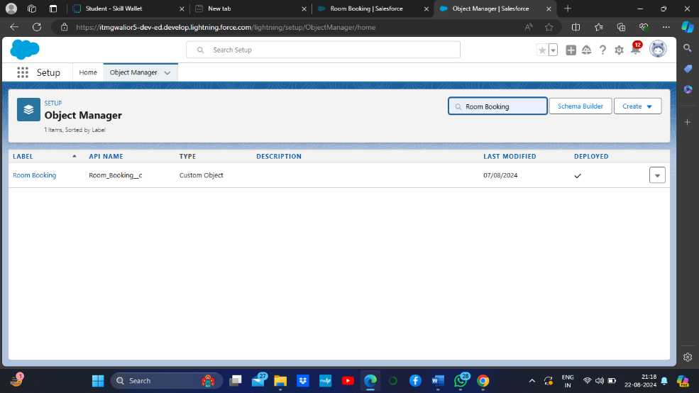

1. Now click on “Fields & Relationships” > New

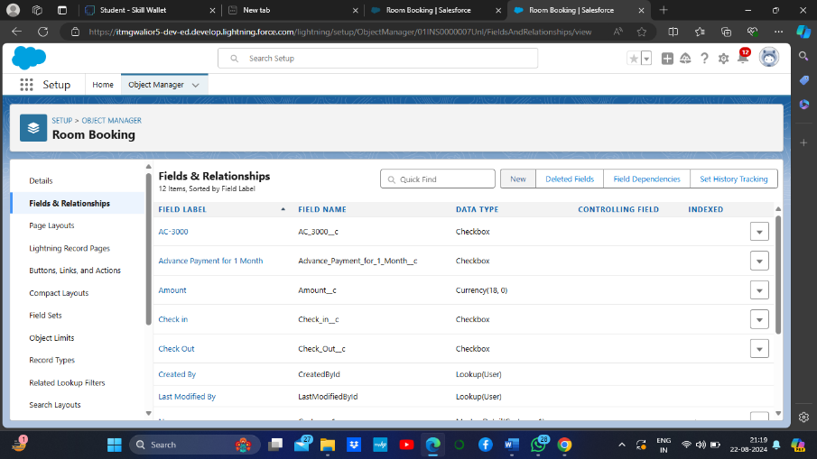

1. 3. Select Data Type as a “Picklist”

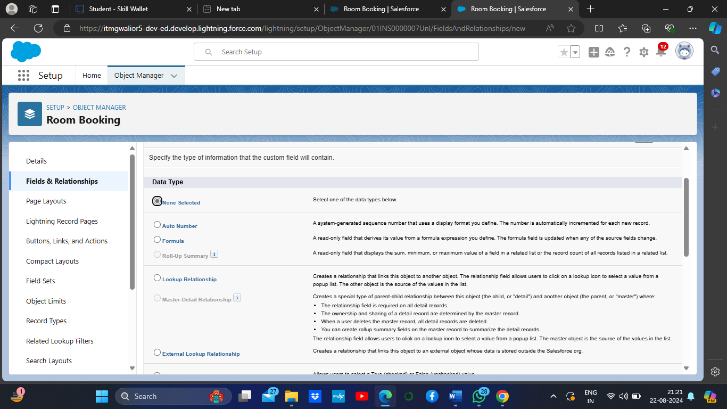

4. Click on Next

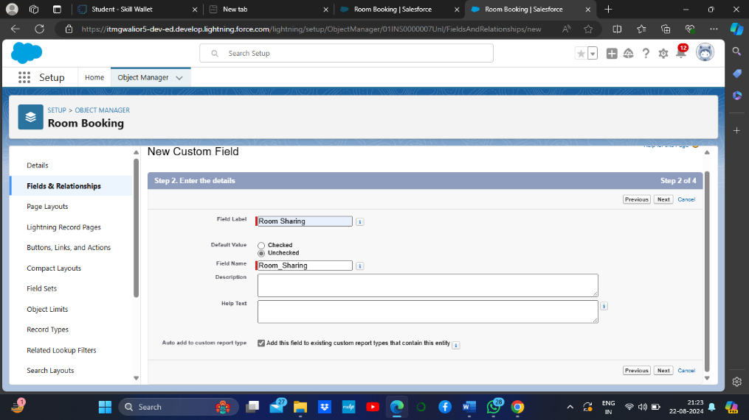

1. Fill the Above as following:

* Field Label: Room Sharing
* Value - Select enter values with each value separated by a new line

1. Single sharing
2. Double sharing
3. Triple sharing

* Select required
* Click on Next > Next > Save and new.

### Creation of Fields & Relationship for Payment1 Object

**1. To create fields & relationship to an object:**

1. Go to setup > click on Object Manager > type object name(Payment1) in the search bar > click on the object.

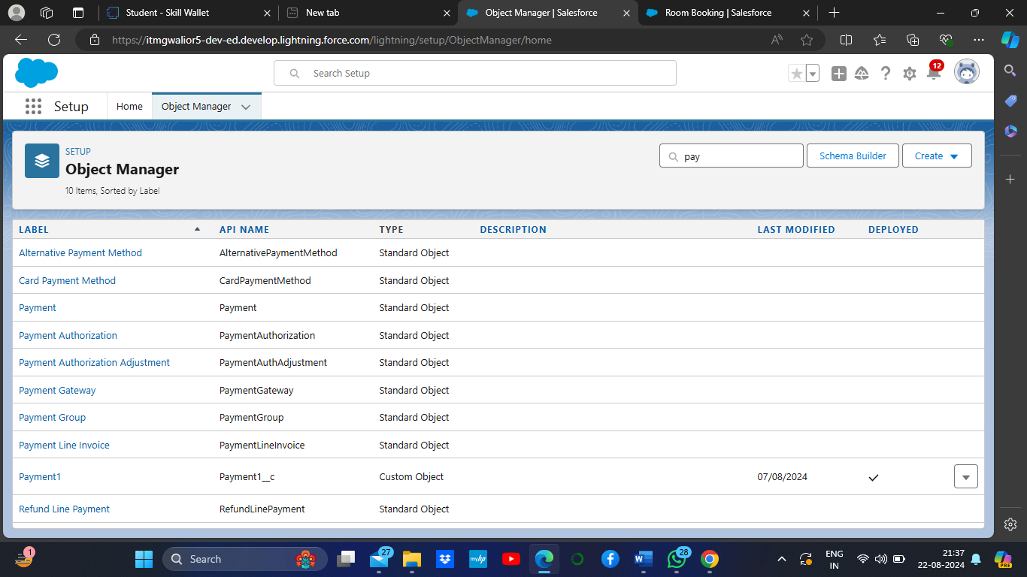

1. Now click on “Fields & Relationships” > New

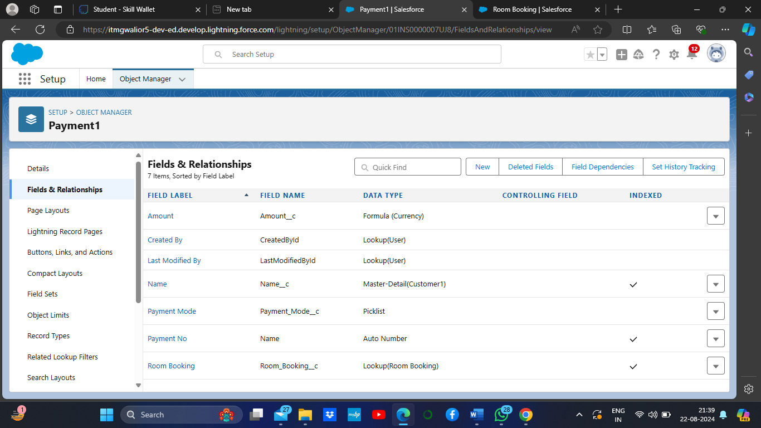

1. Select Data Type as a “Master-detail Relationship”

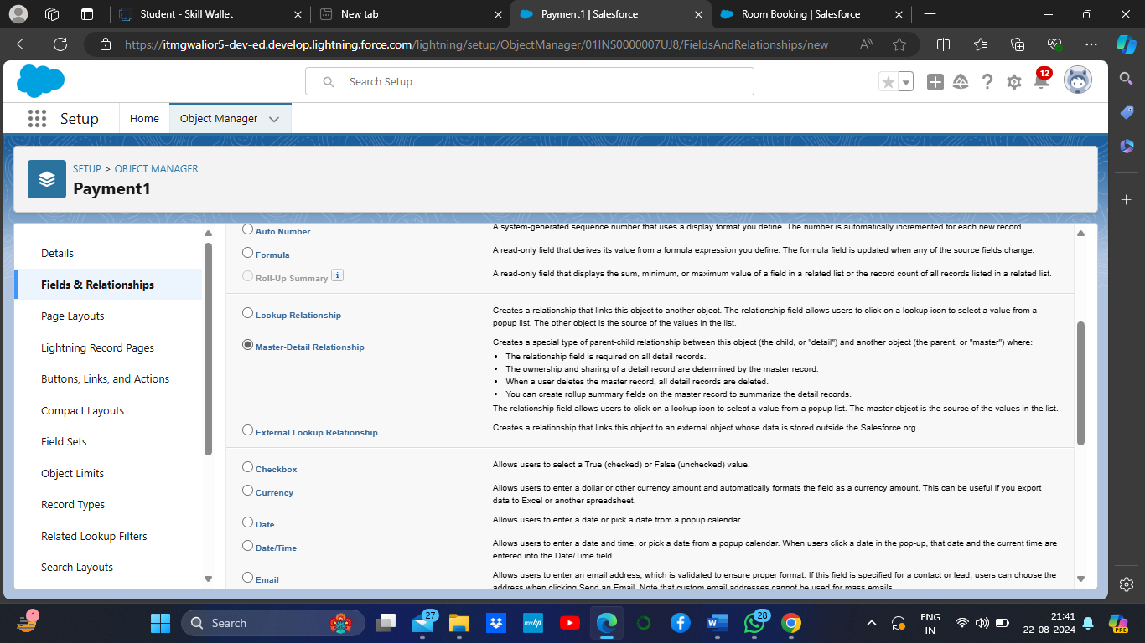

1. Click on Next
2. Click on the Related to drop down and Select the Customer1 object and click on Next

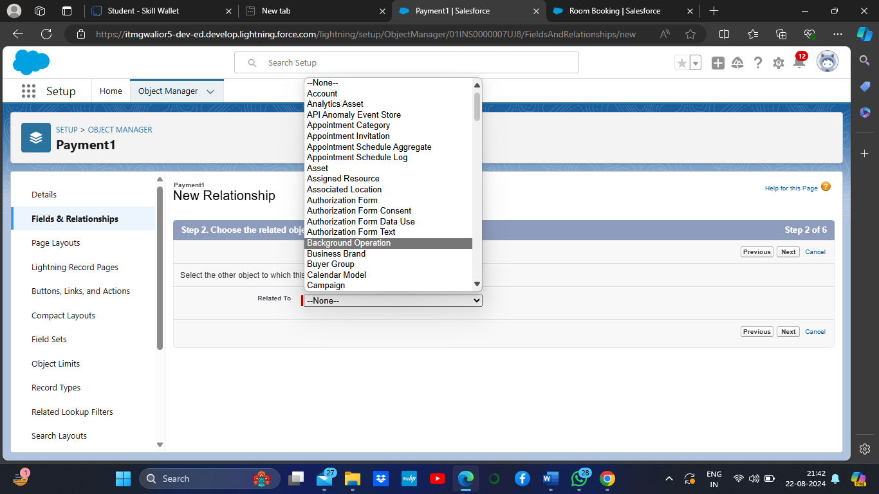

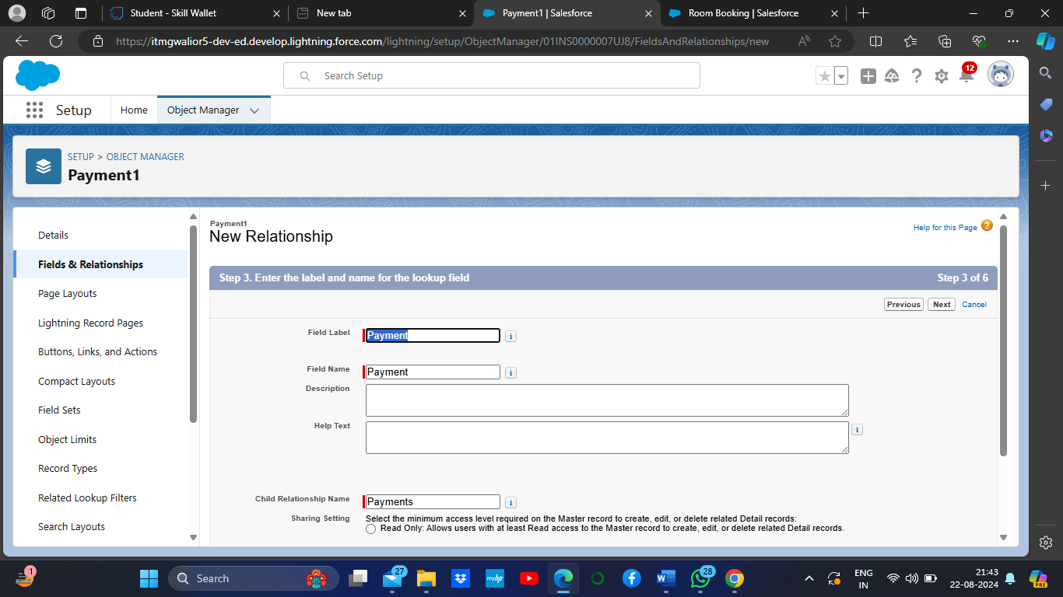

1. Fill the Above as following:

* Change the Field Label: Name
* Field Name :It’s gets auto generated
* Click on Next > Next > Save and new.

Same as make different 6 field & relationship object.

### Task 6-create a validation rule to an Room Booking Object

1. Go to setup > click on Object Manager > type object name(Room Booking) in the search bar > click on the object.
2. Now click on “Validation rule” at top > New.
3. Enter Rule name “checkbox field” and make the validation should be Active.
4. Enter the formula in the formula Box “Advance_payment_for_1month__c  = false” and check for syntax error.
5. Enter the error message “Checkbox should be checked”
6. Select error location as field(Advance payment for 1month)
7. Click on save.

Output SS-

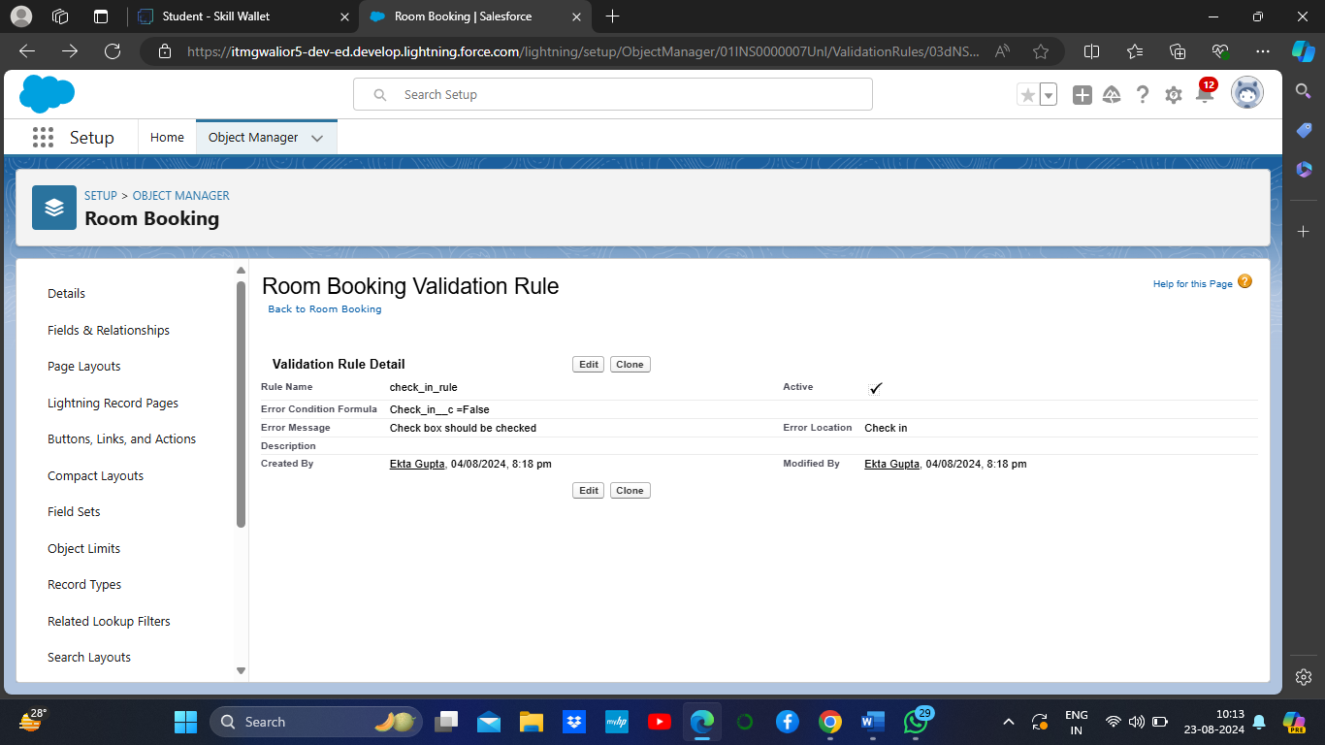

### create a Another validation rule to an Room Booking Object

1. Go to setup > click on Object Manager > type object name(Room Booking) in the search bar > click on the object.
2. Now click on “Validation rule” at top > New.
3. Enter Rule name “check in rule” and make the validation should be Active.
4. Enter the formula in the formula Box “ Check_in__c = False ” and check for syntax error.
5. Enter the error message “Check box should be checked”
6. Select error location as field(Check in
7. Click on save.

Output-

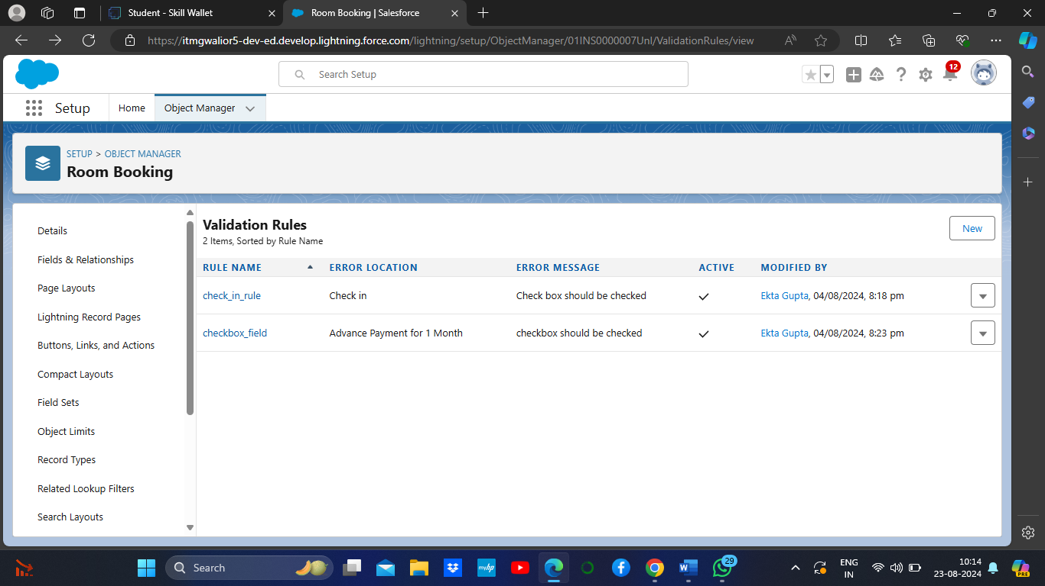

### Task 7-Custom user Profile

**To create a new profile:**

1. Go to setup > type profiles in quick find box > click on profiles > clone the desired profile (Standard User)
2. Enter profile name (Custom User) > Save.
3. While still on the profile page, then click Edit.
4. Scroll down to Custom Object Permissions and Give All access permissions for Customers, Feedbacks, Food selections, Payments, Room Bookings and Total Rooms.
5. Scroll down and Click on Save.

Output ss-

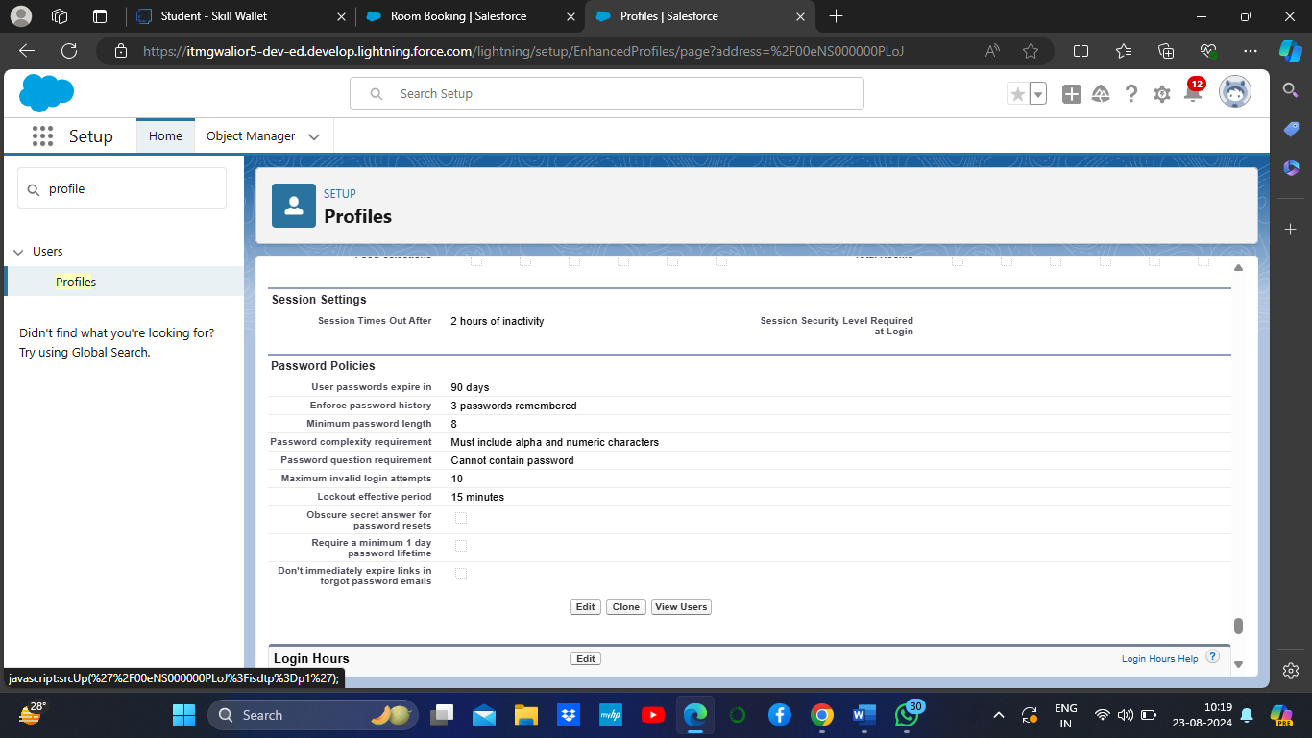

Create two profile customer user1 and customer user2 same as it.

### Task 8-Marketing Role

1. Go to quick find > Search for Roles > click on set up roles.

2.Click on Expand All and click on add role under CEO role.

3.Give Label as “Marketing” and Role name gets auto populated.

4.Then click on Save.

Output-

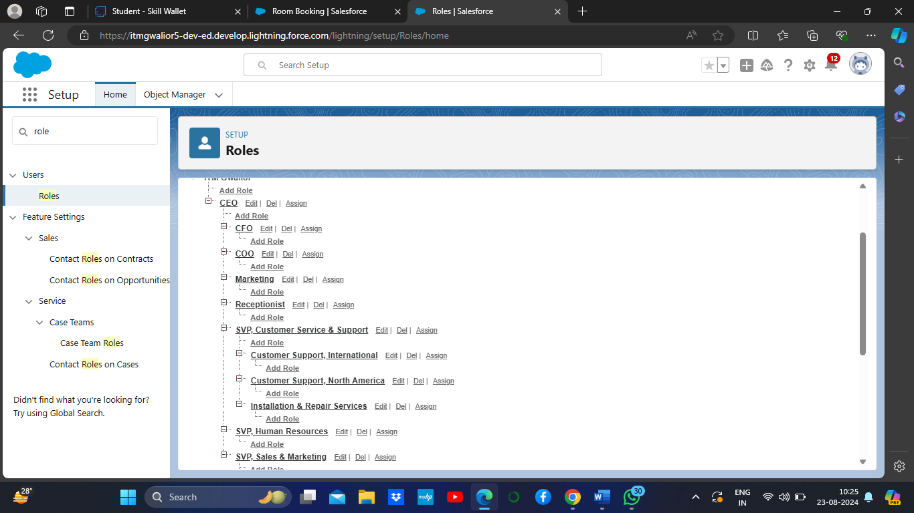

### Receptionist Role

1. Go to quick find > Search for Roles > click on set up roles.
2. Click on Expand All and click on add role under CEO role.
3. Give Label as “Receptionist” and Role name gets auto populated.
4. Then click on Save.

Output-

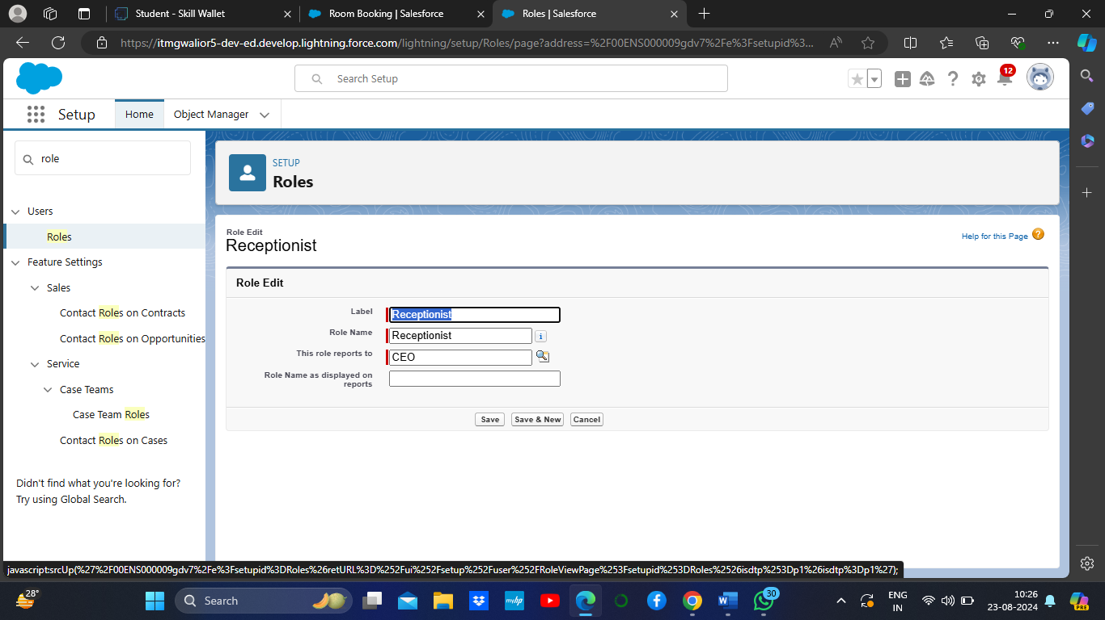

### Task 9-Create User

1. Go to setup > type users in quick find box > select users > click New user.
2. Fill in the fields

* First Name : sandeep
* Last Name : gujja
* Alias : Give a Alias Name
* Email id : Give your Personal Email id
* Username : Username should be in this form: text@text.com
* Nick Name : Give a Nickname
* Role   : CEO
* User licence : Salesforce
* Profiles   : Custom user

1. save.

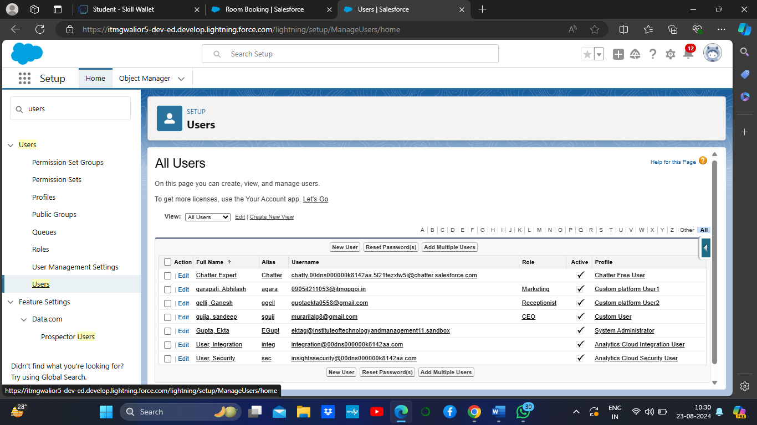

### Create Another User

1. Go to setup > type users in quick find box > select users > click New user.
2. Fill in the fields

* First Name : Abhilash
* Last Name : garapati
* Alias           : Give a Alias Name
* Email id : Give your Personal Email id
* Username : Username should be in this form: text@text.com
* Nick Name : Give a Nickname
* Role : Marketing
* User licence: Salesforce platform
* Profiles : Custom Platform User1

1. Save

### Create Another User

1. Go to setup > type users in quick find box > select users > click New user.
2. Fill in the fields

* First Name : Ganesh
* Last Name : gelli
* Alias : Give a Alias Name
* Email id : Give your Personal Email id
* Username : Username should be in this form: text@text.com
* Nick Name: Give a Nickname
* Role : Receptionist
* User licence: Salesforce Platform
* Profiles : Custom Platform user2

1. Save

### Task 10-Create a Record (Customers)

1. Click on App Launcher on the left side of the screen.
2. Search Home Feels & click on it.
3. Click on the Customers Tab.
4. Click new and fill details & Save

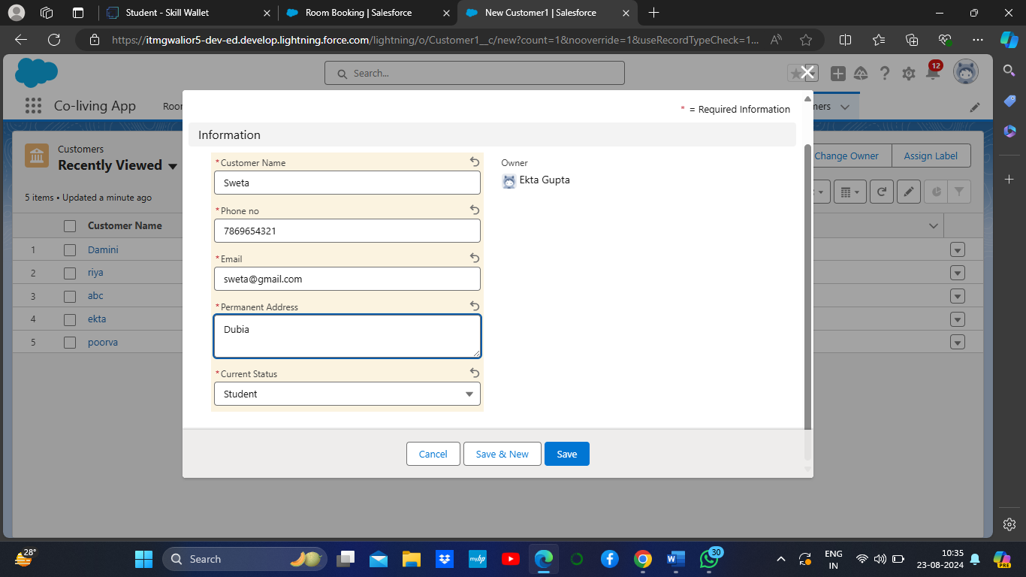

### View a Record (Customers)

1. Click on App Launcher on the left side of the screen.
2. Search Home Feels & click on it.
3. Click on Customer Tab.
4. Click on any record name. you can see the details of the Customer.

### Delete a Record (Customers)

1. Click on App Launcher on the left side of the screen.
2. Search Home Feels & click on it.
3. Click on the Customers Tab.
4. Click on Arrow at right hand side on that Particular record.
5. Click delete and delete again.

### Task 11-Create Report

1. Go to the app > click on the reports tab
2. Click New Report.
3. Select report type from category or from report type panel or from search panel “Customers with Room Bookings with Total Rooms ” > click on start report.
4. Customize your report
5. Add fields from left pane as shown below
6. Save or run it.

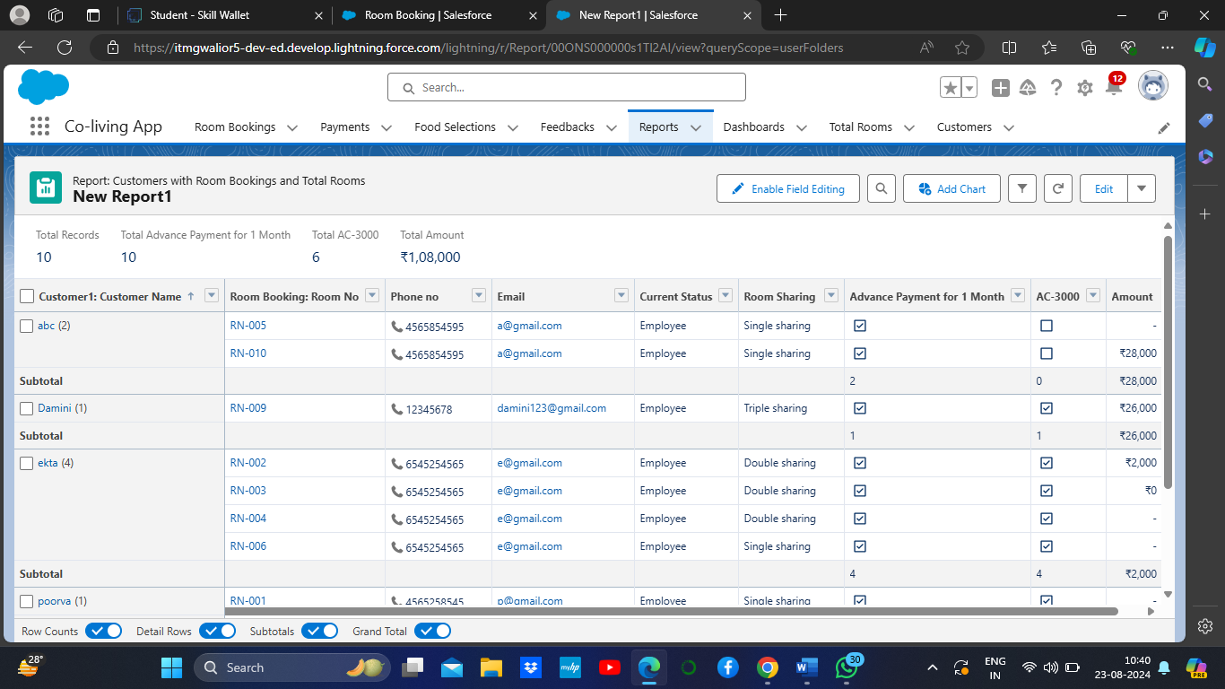

### Create another Report

1. Go to the app > click on the reports tab
2. Click New Report.
3. Select report type from category or from report type panel or from search panel Select customer with Room booking with Payments ? click on start report.
4. Customize your report
5. Add fields from left pane as shown Above
6. Save or run it.

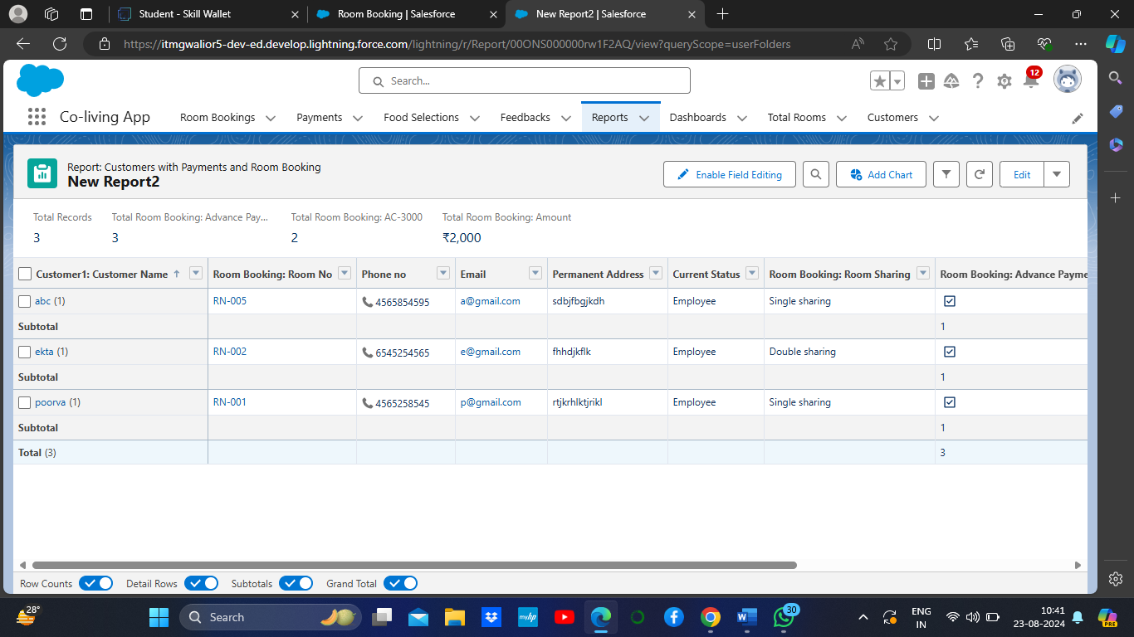

### Task 12-Create Dashboard

1. Go to the app > click on the Dashboard tabs and click on new Dashboard
2. Give a Name and click on Create.
3. Select add component.
4. Select a Report Customer with Room Booking and click on select.
5. Click Add then click on Save and then click on Done.

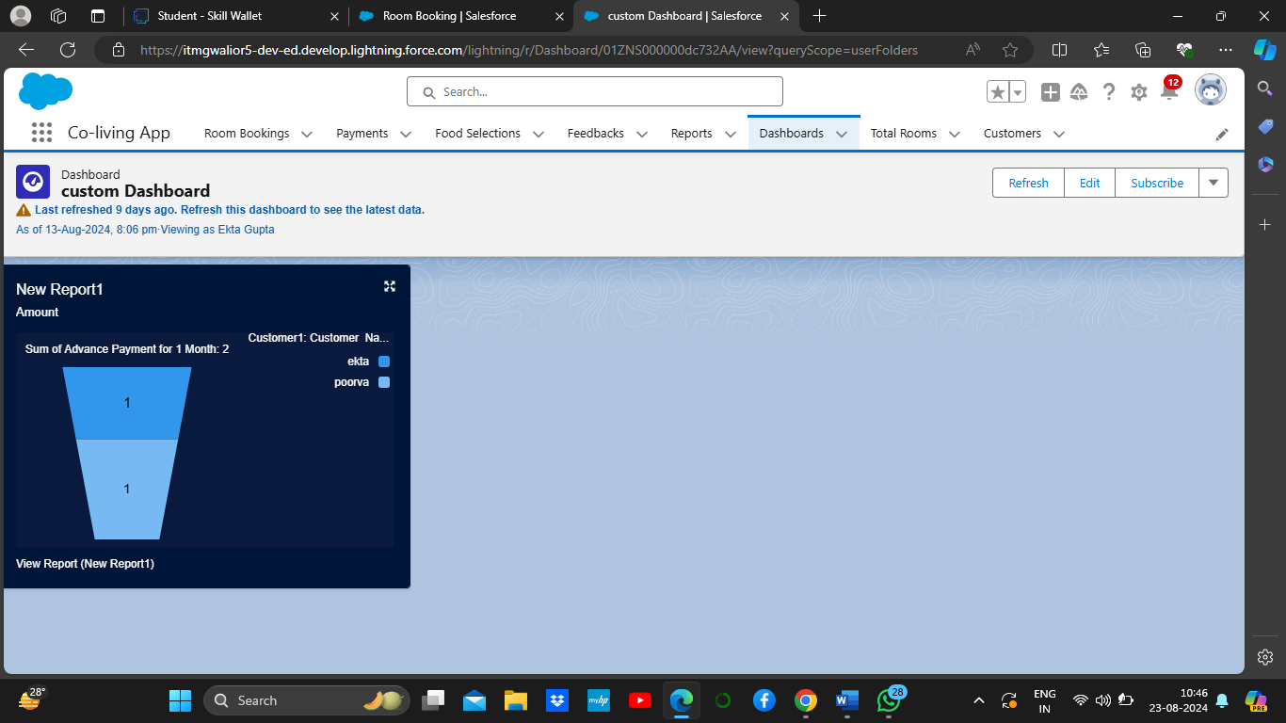

### Task 13-Create a Flow

1. Go to setup > type Flow in quick find box > Click on the Flow and Select the New Flow
2. Select the Record-triggered flow and Click on Create.3
3. Select the Object as a Room Booking in the Drop down list.
4. Select the Trigger Flow when: “A record is Created or Updated”.
5. Select the Optimize the flow for: “Actions and Related Records” and Click on Done.
6. Under the Record-triggered Flow Click on “+” Symbol and In the Drop down List select the “Decision Element”.
7. Enter the Details Label: Field should be Update, API name: Gets Automatically Generated.
8. Enter the Outcome Details Label: Single sharing, Outcome API name: Gets Automatically Generated.

* Resource: Select Record.Room sharing.
* Operator: Select Equals.
* Value: Select Single sharing.
* Click on “Add Condition”
* Resource: Select Record.AC-3000.
* Operator: Select Equals.
* Value: Select False.
* Click on “+” Symbol In the Outcome Order.

Repeat this process for Double sharing,Triple sharing.

9.Enter the update records details

* Label: Single ac1.
* API name: Gets automatically Generated.
* Under the Set Field Values for the Room Booking Record.
* Field: Amount.
* Value: 34000.
* Click on Done.

Repeat this process for the Double ac2,Triple ac3.

Output SS-

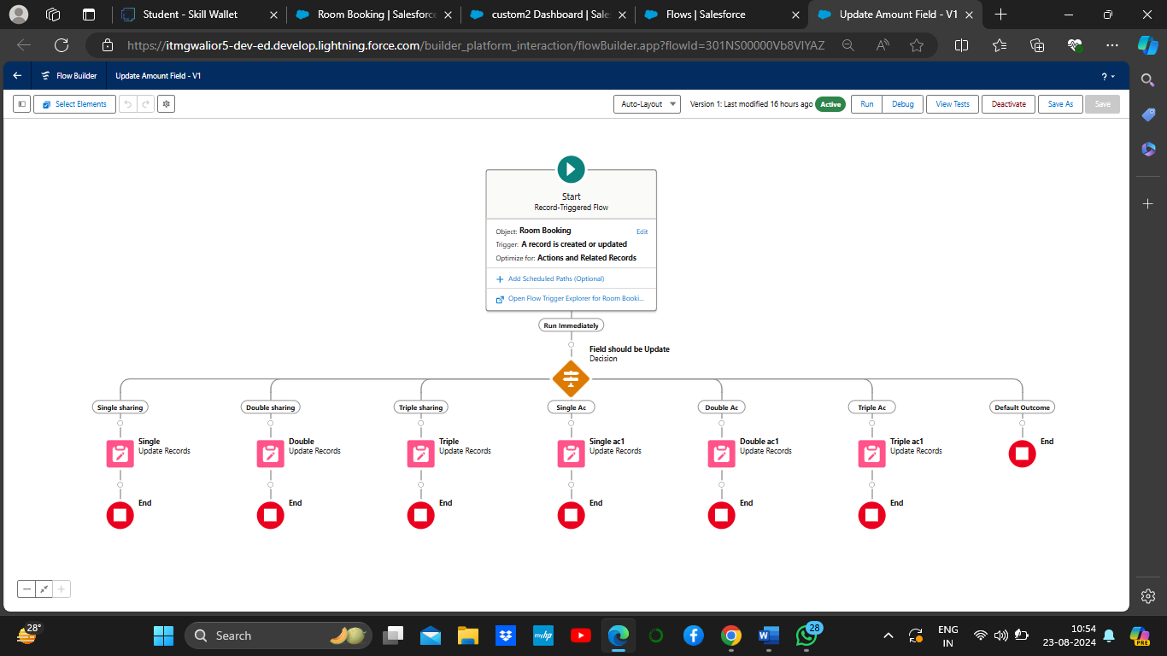

### Test the Flow

1. Go to App Launcher and search for Co-living and select the app.
2. In the Co-living app click on the Room sharing tab and click on new.
3. Enter the details like Name, Room sharing, Ac-3000, Advance payment for 1 Month. And the Amount field is empty before saving the record.

13.After saving the record the amount gets reflected in the Amount field by using the given flows.

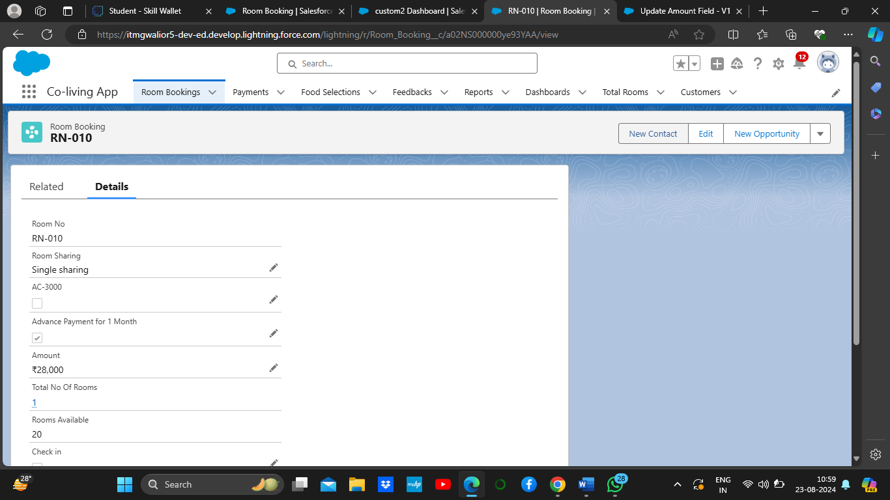

Thank You